WITHDRAWAL NOTICE
DETERMINATION OF SIGNIFCANCE

Application Nos.: CAO15-001 (Reasonable Use Exception) and SEP15-001 (SEPA review)
Description of proposal: The applicant is proposing to locate a single-family residence in a Category III wetland and its associated buffer, and in a Type 2 watercourse buffer; the proposed single-family residence will have a building footprint of approximately 1,600 square feet and will result in direct wetland impacts. The subject lot is significantly encumbered by environmentally critical areas and their associated buffers. The applicant has requested a Reasonable Use Exception to allow for construction of the proposed single-family residence and associated improvements. Environmentally critical areas present on site include the following: wetland areas and associated buffers; watercourses and associated buffers; and landslide, seismic, and erosion hazard areas.
The applicant has proposed to modify the application and incorporate additional mitigation, such that the previously issued (July 17, 2017) Determination of Significance has been withdrawn.
Proponent: MI Treehouse, LLC (c/o Bill Summers)
Location of proposal: 5637 East Mercer Way, Mercer Island WA 98040;
Identified by King County Assessor tax parcel number 1924059312
Lead agency: City of Mercer Island

Responsible Official: Evan Maxim, Director of Community Planning and Development
City of Mercer Island
9611 SE 36th Street

Mercer Island, WA 98040

Email: Evan.maxim@mercergov.org

Mercer Island is withdrawing the SEPA threshold Determination of Significance issued on July 17, 2017 pursuant to WAC 197-11-360(4). If a new threshold determination is issued, then a new notice and comment period will be provided.

Date: August 19, 2019
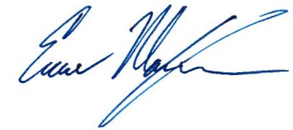
Signature:

